Spring MVC:

MVC - Model View Controller
Used to design dynamic web applications
Internally uses 3 different design patterns: Front Controller, Handler Mapper & View Resolver

Flow & various components involved:
Step 1: When a HTTP request comes from Client, the first component to handle is Dispatcher Servlet which is an implementation of Front Controller design pattern; Client request to Dispatcher Servlet (Front Controller); It is configured in web.xml, which is a deployment descriptor; DS is from Spring framework, will not be writing any servlets & will configure it in web.xml
Step 2: DS will use Handler Mapper to invoke a Controller; Controller is a pojo class that we create & mark with @Controller annotation
Step 3: Controller will implement a method that creates a Model & View (Model is Optional to keep data; view is the next page to be displayed);
Step 4: At the end the Controller should return the Model & View to the dispatcher servlet; name of the View;
Step 5: Dispatcher will take the view name & will invoke a View Resolver (a component)
Step 6: View Resolver will append a Prefix (location) & Suffix (Extension) and returns a complete view back to DS; This way controller is not coupled with a view; (For example: We can have view location in server that could be WebInf pages, tomorrow if you have move to different location you will change in configuration file instead of touching controller; similarly if you want to switch from jsp to jsf, we do by simply changing the suffix in configuration)
Step 7: DS will take that view & render the page back to client; (the page can use the Model, if there is data)
Steps to create MVC Application:
- Configure Dispatcher Servlet (in web.xml)
- Create Spring Configuration file (in web inf folder)
- Configure View Resolver in the configuration file
- Controller class with model view method (POJO class with @Controller)
- Create the view & store in a folder (view is a jsp file)
Pre-set up:
- Install TomCat server & map it with IDE
- Create Spring MVC project & set up configurations

View full path:
/WEB-INF/views/hello.jsp

Example:
Folder Structure:
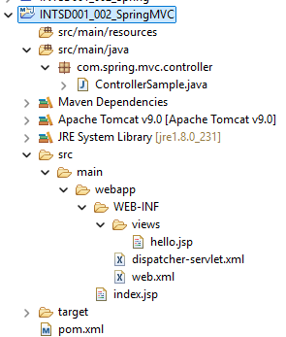
Pom.xml:
<project xmlns="http://maven.apache.org/POM/4.0.0" xmlns:xsi="http://www.w3.org/2001/XMLSchema-instance"
xsi:schemaLocation="http://maven.apache.org/POM/4.0.0 http://maven.apache.org/maven-v4_0_0.xsd">
<modelVersion>4.0.0</modelVersion>
<groupId>com.spring.mvc</groupId>
<artifactId>INTSD001_002_SpringMVC</artifactId>
<packaging>war</packaging>
<version>0.0.1-SNAPSHOT</version>
<name>INTSD001_002_SpringMVC Maven Webapp</name>
<url>http://maven.apache.org</url>
<properties>
<project.build.sourceEncoding>UTF-8</project.build.sourceEncoding>
<maven.compiler.source>1.7</maven.compiler.source>
<maven.compiler.target>1.7</maven.compiler.target>
</properties>

<dependencies>

<dependency>
<groupId>org.springframework</groupId>
<artifactId>spring-webmvc</artifactId>
<version>5.3.18</version>
</dependency>

<dependency>
<groupId>junit</groupId>
<artifactId>junit</artifactId>
<version>3.8.1</version>
<scope>test</scope>
</dependency>
</dependencies>
<build>
<pluginManagement><!-- lock down plugins versions to avoid using Maven defaults (may be moved to parent pom) -->
<plugins>
<plugin>
<artifactId>maven-compiler-plugin</artifactId>
<version>3.10.1</version>
<configuration>
<source>1.8</source>
<target>1.8</target>
</configuration>
</plugin>
</plugins>
</pluginManagement>

<finalName>INTSD001_002_SpringMVC</finalName>
</build>
</project>

Web.xml:
<!DOCTYPE web-app PUBLIC
"-//Sun Microsystems, Inc.//DTD Web Application 2.3//EN"
"http://java.sun.com/dtd/web-app_2_3.dtd" >

<web-app>
<display-name>SDET MVC Project</display-name>

<servlet>
<servlet-name>dispatcher</servlet-name>
<servlet-class>org.springframework.web.servlet.DispatcherServlet</servlet-class>
</servlet>

<servlet-mapping>
<servlet-name>dispatcher</servlet-name>
<url-pattern>/</url-pattern>
</servlet-mapping>
</web-app>

Configuration file (dispatcher-servlet.xml):
<?xml version="1.0" encoding="UTF-8"?>
<beans
xmlns="http://www.springframework.org/schema/beans"
xmlns:xsi="http://www.w3.org/2001/XMLSchema-instance"
xmlns:context="http://www.springframework.org/schema/context"

xsi:schemaLocation="http://www.springframework.org/schema/beans
http://www.springframework.org/schema/beans/spring-beans-3.0.xsd
http://www.springframework.org/schema/context
http://www.springframework.org/schema/context/spring-context.xsd">

<context:component-scan base-package="com.spring.mvc.controller"></context:component-scan>

<bean class="org.springframework.web.servlet.view.InternalResourceViewResolver" name="viewResolver">
<property name="prefix">
<value>/WEB-INF/views/</value>
</property>
<property name="suffix">
<value>.jsp</value>
</property>
</bean>
</beans>

Controller Class:
package com.spring.mvc.controller;

import org.springframework.stereotype.Controller;
import org.springframework.web.bind.annotation.RequestMapping;
import org.springframework.web.servlet.ModelAndView;

@Controller
public class ControllerSample {

@RequestMapping("/hello")
public ModelAndView hello(){

ModelAndView mv = new ModelAndView();
mv.setViewName("hello");
return mv;
}
}

Default Jsp file:
<html>
<body>
<h2>Hello World!</h2>
</body>
</html>

Hello.jsp:
<%@ page language="java" contentType="text/html; charset=ISO-8859-1"
pageEncoding="ISO-8859-1"%>
<!DOCTYPE html PUBLIC "-//W3C//DTD HTML 4.01 Transitional//EN" "http://www.w3.org/TR/html4/loose.dtd">
<html>
<head>
<meta http-equiv="Content-Type" content="text/html; charset=ISO-8859-1">
<title>SDET Program</title>
</head>
<body>
<h1>Welcome to Cognizant</h1>
<h2>This is Internship Program</h2>
</body>
</html>
Output:
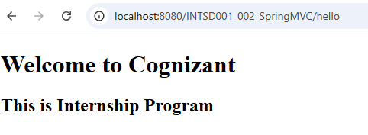

Data Exchange:
- Controller to UI
- UI to Controller

1. Controller to UI
- Data is passed to ModelandView object
- Uses addObject(key,value) method to set data (key - Java String; value - Object)
- Data is accessed in jsp page using request.getAttribute(“key”) - here “request” is http servlet request object, thru “key” value is accessed)
- Object - may be of Primitive, Object or Collection type

Folder Structure:
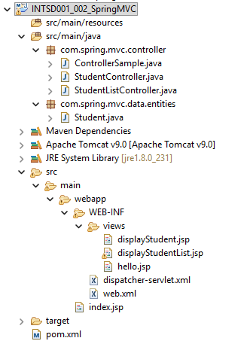
a) Sending Primitive Data Type:

Update the previous Controller Class:
package com.spring.mvc.controller;

import org.springframework.stereotype.Controller;
import org.springframework.web.bind.annotation.RequestMapping;
import org.springframework.web.servlet.ModelAndView;

@Controller
public class ControllerSample {

@RequestMapping("/hello")
public ModelAndView hello(){

ModelAndView mv = new ModelAndView();
mv.setViewName("hello");
mv.addObject("id", 123);
mv.addObject("name", "Chris Evans");
mv.addObject("course", "BTech");
return mv;
}
}

Update the previous Jsp file:
<%@ page language="java" contentType="text/html; charset=ISO-8859-1"
pageEncoding="ISO-8859-1"%>
<!DOCTYPE html PUBLIC "-//W3C//DTD HTML 4.01 Transitional//EN" "http://www.w3.org/TR/html4/loose.dtd">
<html>
<head>
<meta http-equiv="Content-Type" content="text/html; charset=ISO-8859-1">
<title>SDET Program</title>
</head>
<body>
<h1>Welcome to Cognizant</h1>
<h2>This is Internship Program</h2>
<%
Integer id = (Integer)request.getAttribute("id");
String name = (String)request.getAttribute("name");
String course = (String)request.getAttribute("course");
out.println("ID : " + id);
out.println("Name : " + name);
out.println("Course : " + course);
%>

</body>
</html>
Output:
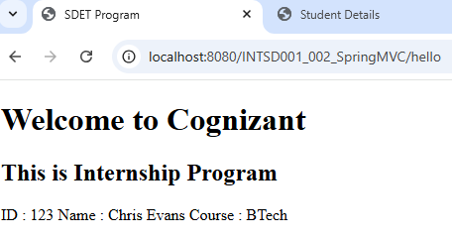

b)Sending Object Data Type:

New Data Class:
package com.spring.mvc.data.entities;

public class Student {

public int id;
public String name;
public String Course;

public int getId() {
return id;
}
public void setId(int id) {
this.id = id;
}

public String getName() {
return name;
}
public void setName(String name) {
this.name = name;
}

public String getCourse() {
return Course;
}
public void setCourse(String course) {
Course = course;
}

@Override
public String toString() {
return "Student [id=" + id + ", name=" + name + ", Course=" + Course + "]";
}

}

New Controller Class:
package com.spring.mvc.controller;

import org.springframework.stereotype.Controller;
import org.springframework.web.bind.annotation.RequestMapping;
import org.springframework.web.servlet.ModelAndView;

import com.spring.mvc.data.entities.Student;

@Controller
public class StudentController {

@RequestMapping("/readStudent")
public ModelAndView sendStudent(){

ModelAndView mv1 = new ModelAndView();
mv1.setViewName("displayStudent");

Student s = new Student();
s.setId(131);
s.setName("Roger Fed");
s.setCourse("MTech");

mv1.addObject("student", s);
return mv1;
}
}

New Jsp file:
<%@ page language="java" contentType="text/html; charset=ISO-8859-1"
pageEncoding="ISO-8859-1"%>
<!DOCTYPE html PUBLIC "-//W3C//DTD HTML 4.01 Transitional//EN" "http://www.w3.org/TR/html4/loose.dtd">
<html>
<head>
<meta http-equiv="Content-Type" content="text/html; charset=ISO-8859-1">
<title>Student Details</title>
</head>
<body>
<h1>Welcome to Cognizant</h1>
<%=request.getAttribute("student")%>
</body>
</html>
Output:

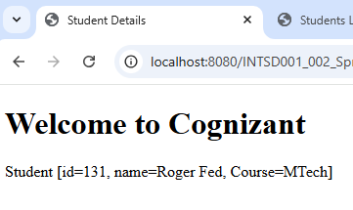

c)Sending Collection Data Type:

New Controller Class:
package com.spring.mvc.controller;

import java.util.ArrayList;

import org.springframework.stereotype.Controller;
import org.springframework.web.bind.annotation.RequestMapping;
import org.springframework.web.servlet.ModelAndView;

import com.spring.mvc.data.entities.Student;

@Controller
public class StudentListController {

@RequestMapping("/readStudentList")
public ModelAndView sendStudentList(){

ModelAndView mv2 = new ModelAndView();
mv2.setViewName("displayStudentList");

Student s1 = new Student();
s1.setId(131);
s1.setName("Roger Fed");
s1.setCourse("MTech");

Student s2 = new Student();
s2.setId(132);
s2.setName("Martina Hingis");
s2.setCourse("MBA");

Student s3 = new Student();
s3.setId(133);
s3.setName("Steffi Graf");
s3.setCourse("BSc");

ArrayList<Student> studList = new ArrayList<Student>();
studList.add(s1);
studList.add(s2);
studList.add(s3);

mv2.addObject("students", studList);
return mv2;
}
}

New Jsp file:
<%@ page language="java" contentType="text/html; charset=ISO-8859-1"
pageEncoding="ISO-8859-1"
import = "java.util.List, com.spring.mvc.data.entities.Student"
%>
<!DOCTYPE html PUBLIC "-//W3C//DTD HTML 4.01 Transitional//EN" "http://www.w3.org/TR/html4/loose.dtd">
<html>
<head>
<meta http-equiv="Content-Type" content="text/html; charset=ISO-8859-1">
<title>Students List</title>
</head>
<body>
<h1>Welcome to Cognizant</h1>
<%
List<Student> students = (List<Student>)request.getAttribute("students");
for(Student s: students){
out.println("ID : " + s.getId());
out.println("Name : " + s.getName());
out.println("Course : " + s.getCourse());
}
%>
</body>
</html>
Output:
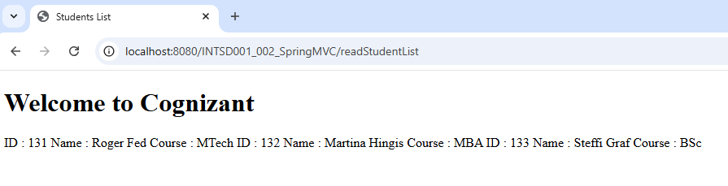

- Sending Data from UI to Controller:
Done in 2 ways:
- HTML Form
- Query Parameters

a) HTML Form:
- Form Data is submitted from web browser
The spring container does 4 things here
  - Read – Read all the data using Requst.getParameter method
  - Convert – convert into appropriate java type using integer.parseInt, double.parseDouble etc, with all other parse methods
  - CreatesObject – create the object of the model class & sets all the values that comes into object
  - SetsValues – Handover the object by setting values to controller
- Data is accessed in Controller class as an object

How to Action it?
1. Define the Model class with properties needed (the number of properties & their name should match the # of fields & name in html form)
2. Container will read the data comes in, creates object of this class, set the values & hands over to controller
3. To read the values, use @ModelAttribute annotation in the method parameters

Example:
New jsp file for Registration Form (studentRegistraion.jsp):
<%@ page language="java" contentType="text/html; charset=ISO-8859-1"
pageEncoding="ISO-8859-1"%>
<!DOCTYPE html PUBLIC "-//W3C//DTD HTML 4.01 Transitional//EN" "http://www.w3.org/TR/html4/loose.dtd">
<html>
<head>
<meta http-equiv="Content-Type" content="text/html; charset=ISO-8859-1">
<title>Student Registration Form</title>
</head>
<body>
<form action="registerStudent" method="post">
<pre>
Id : <input type="text" name="id"/>
Name : <input type="text" name="name"/>
Course : <input type="text" name="course"/>
<input type="submit" name="register"/>
</pre>
</form>
</body>
</html>

New Controller class (StudentRegController)
package com.spring.mvc.controller;

import org.springframework.stereotype.Controller;
import org.springframework.web.bind.annotation.ModelAttribute;
import org.springframework.web.bind.annotation.RequestMapping;
import org.springframework.web.bind.annotation.RequestMethod;
import org.springframework.web.servlet.ModelAndView;

import com.spring.mvc.data.entities.Student;

@Controller
public class StudentRegController {

@RequestMapping("/registrationPage")
public ModelAndView showRegPage(){
ModelAndView mv3 = new ModelAndView();
mv3.setViewName("studentRegistration");
return mv3;
}

@RequestMapping(value="registerStudent", method=RequestMethod.POST)
public ModelAndView registerStudent(@ModelAttribute("student") Student student){

System.out.println(student);
ModelAndView mv4 = new ModelAndView();
// mv4.setViewName("studentRegistration");

mv4.addObject("student", student);
mv4.setViewName("studentRegResponse");
return mv4;
}
}

Output with same registration page:
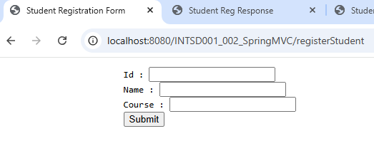
New jsp file for Response page (studentRegResponse.jsp)
<%@ page language="java" contentType="text/html; charset=ISO-8859-1"
pageEncoding="ISO-8859-1"%>
<!DOCTYPE html PUBLIC "-//W3C//DTD HTML 4.01 Transitional//EN" "http://www.w3.org/TR/html4/loose.dtd">
<html>
<head>
<meta http-equiv="Content-Type" content="text/html; charset=ISO-8859-1">
<title>Student Reg Response</title>
</head>
<body>
Student Registered Successfully !!! Student Details are ...
<%=request.getAttribute("student") %>
</body>
</html>
Output with new jsp page:
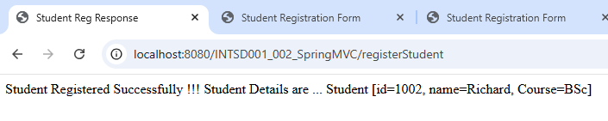

b) Query Parameters
- By using Request Parameters or Query Parameters
- Data is sent by appending at the end of URL using query string (?key=value; more than one key value pair is separated with & symbol)
- The data is retrieved in controller by using @RequestParam -> give the key & spring will retrieve the value & set it in controller method parameter (@RequestParam(“key”)DT methodParam) - DT is DataType like Integer, Double, String.
For example:
@RequestParam(“id”)int id - if this is given, spring internally will do the following:
- String sid = request.getParameter(“id”);
- int id = Integer.parseInt(id);

- Controller will receive data as string & converts into integer
- If invalid data, it will throw 400 error
- If value not provided, it will throw null error
- If you want to set it optional, add a parameter as “required=false”
- If you want to set default value, add a parameter “defaultValue”

Example:
New controller class (RequestParamController)
package com.spring.mvc.controller;

import org.springframework.stereotype.Controller;
import org.springframework.web.bind.annotation.RequestMapping;
import org.springframework.web.bind.annotation.RequestParam;
import org.springframework.web.servlet.ModelAndView;

@Controller
public class RequestParamController {

@RequestMapping("/showData")
public ModelAndView showData(@RequestParam("id") int id,
@RequestParam("name") String name,
@RequestParam(value="course", required=false, defaultValue="BTech") String course){

System.out.println("Id : " + id);
System.out.println("Name : " + name);
System.out.println("Course : " + course);
return new ModelAndView("studentRegistration");
}
}

Query Parameter:
http://localhost:8080/INTSD001_002_SpringMVC/showData?id=1234&name=Jack&course=MSc

Output:
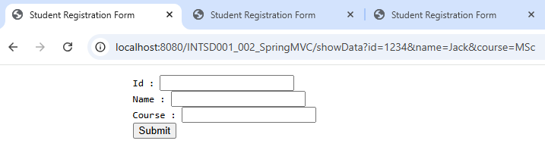
INFO: Completed initialization in 6543 ms
Id : 1234
Name : Jack
Course : MSc

Query Parameter with parameter set as optional:
http://localhost:8080/INTSD001_002_SpringMVC/showData?id=1234&name=Jack
Output:
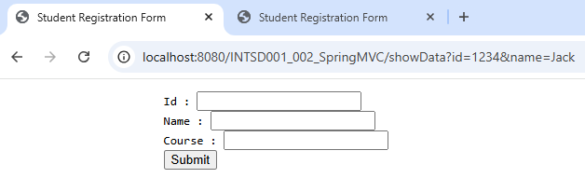
INFO: Completed initialization in 9385 ms
Id : 1234
Name : Jack
Course : null

Query Parameter with default value for parameter:
http://localhost:8080/INTSD001_002_SpringMVC/showData?id=1234&name=Jack

Output:
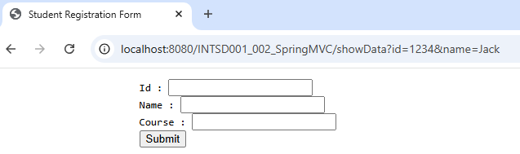
INFO: Completed initialization in 12119 ms
Id : 1234
Name : Jack
Course : BTech

